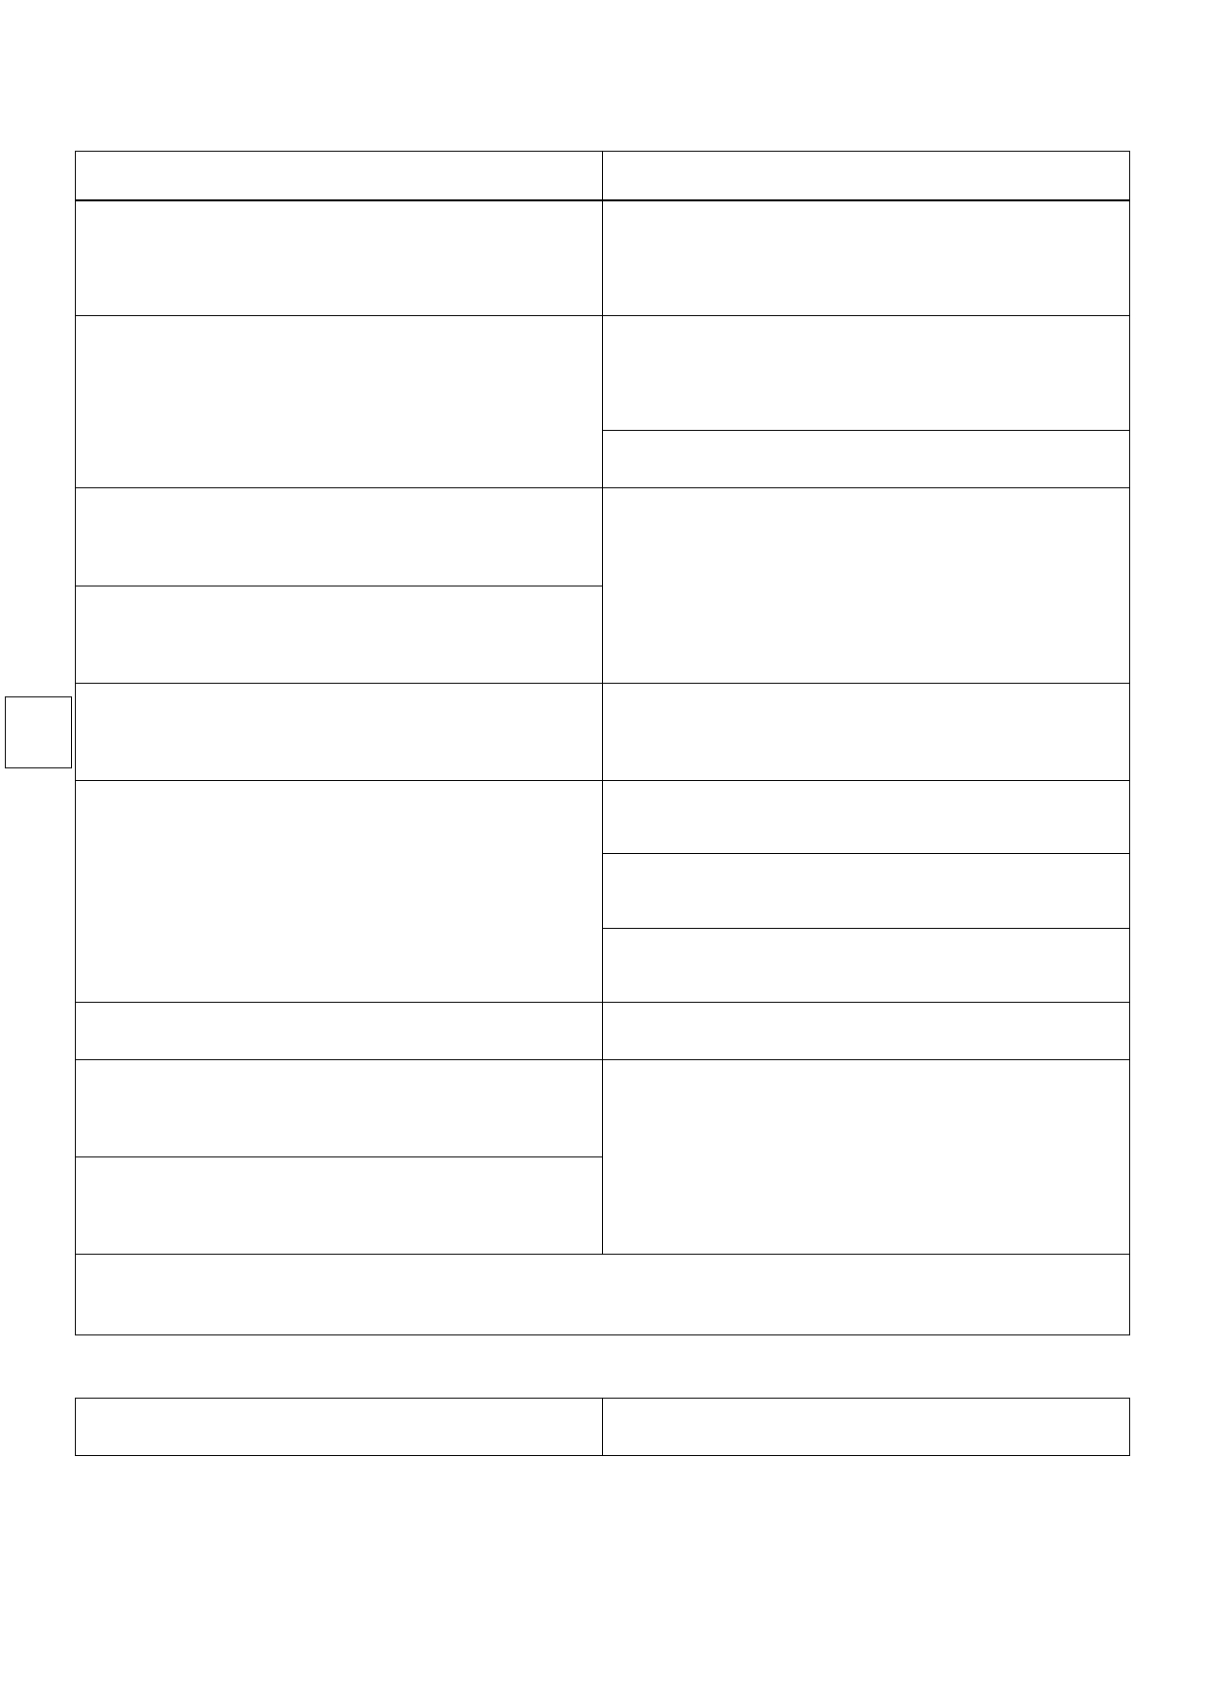
CONTINENT GRAIN CHARTERPARTY
The Baltic and International Maritime Council (BIMCO)
The Documentary Commitee of
Approved by
"SYNACOMEX" AND "COMITÉ CENTRAL DES ARMATEURES DE FRANCE"
Copyright published by

Code name: "SYNACOMEX 2000"
Adopted PARIS 1957 by SYNDICAT NATIONAL DU COMMERCE EXTÉRIEUR DES CEREALES
ammended 1960, 1974, 1990 and 2000 in agreement with COMITÉ CENTRAL DES ARMATEURS DE FRANCE
in cooperation with Chambre Arbitrale Maritime de Paris and the French Chartering and S. & P. Brokers' Association

1. Shipbroker(s) VFS Chartering Ltd.
Primorski park 536 No.271, po box 35 9014 Varna, Bulgaria

3. Owners/Place of business (state full style and address) (Cl.1)
SANTANA MARINE LTD,
80, BROAD STREET MONROVIA,
LIBERIA

5. Vessel's name (Cl. 1)
MV SANTANA

flag / built / class: See Cl. 29.

NT / GT: See Cl. 29.

summer DWT: See Cl. 29.

8. Loading port(s) (Cl. 2)
1/2 safe berth(s) in Charterer’s option KHERSON then ILLICHEVSK, UKRAINE in this rotation
a) Always afloat (*) b) "safely aground" (*)

2. Place and date of Charter Party
Varna, 18th January, 2016

4. Charterers/Place of business (state full style and address) (Cl.1)
GLENCORE GRAIN B.V.
ROTTERDAM
THE NETHERLANDS

6. First layday date (Cl. 6) 19th January, 2016

Cancelling date (Cl. 6) 21th January, 2016

7. Present position / expected ready to load (Cl. 1)
See Cl. 29

9. Advance notices (Cl. 7)

-at load port to: on fixing and then 1 day of vessel’s ETA loadport/area
PART I

10. Discharging port(s) (Cl. 3)
1/2 safe berth(s) in Charterer’s option 1 PORT IN MARMARA or in Charterer’s option 1 PORT OUT OF NEMRUT BAY OR IZMIR OR ALIAGA
Port/s and rotation in Charterers option

a) Always afloat (*) b) "safely aground" (*)

11. Cargo nature and quantities (Cl.2)
Minimum 9,000 metric tons up to full and complete cargo in Charterer’s option of SOYABEANS in bulk stowage factor about 49’-50’ cubic feet without guarantee

a) No bags (*) b) Maximum in bags for stowage (*)

13. Freight rate payment (state currency and method of payment, beneficiary
and bank account) (Cl. 4) See Cl. 30.

17. Agents at loading port(s) (Cl. 13)
To be advised

19. Extra insurance, maximum (Cl.14)
N/A
-Glencore Grain Rotterdam B.V., telex + 44 26600 glen nl, fax +31 (10) 4044476
-Agents at loading port – To be advised
-at discharging port: number of days / to: on sailing from loading port and 1 day of vessel’s ETA loadport/area
-Glencore Grain Rotterdam B.V., telex +44 26600 glen nl, fax +31 (10) 4044476
-Agents at discharging port – To be advised

12. Freight rate (Cl. 4)
USD 18.50 pmt bss 2/1 1 PORT IN MARMARA
USD 20.50 pmt bss 2/1 1 PORT OUT OF NEMRUT BAY OR ALIAGA OR IZMIR in Charterer’s option
All rates are basis Fio spout and or grab trimmed.

14. Loading rate (Cl. 4)
1,500 metric tons per weather working day of 24 consecutive hours SSHEX
Time from Friday 5 p.m. until 8 a.m. on Monday and from noon on a day preceding
a legal or local holiday until 8 a.m. next working day not to count, even if used.
15. Discharging rate (Cl. 5)
2,000 metric tons per weather working day of 24 consecutive hours SSHEX
Time from Friday 5 p.m. until 8 a.m. on Monday and from noon on a day preceding
a legal or local holiday until 8 a.m. next working day not to count, even if used.
16. Demurrage / Despatch money (Cl. 9)
USD 5,000 / Free despatch both ends

18. Agents at discharging port(s) ( Cl. 13)
To be advised

20. Brokerage commission and to whom payable (Cl. 15)
1.25 percent to VFS Chartering Ltd. on freight, deadfreight, detention and demurrage

21. AddressP Commission (Cl. 16)
2.5 percent to the Charterers on freight, deadfreight, detention and demurrage

a) Deductible(*) b) Non-deductible (*)

22. Number of additional clauses covering special provisions, if any agreed
Additional Clauses 29 to 48 inclusive.

It is mutually agreed that this Charter Party shall be performed subject to the conditions contained herein consisting of PART I and PART II including additional
clauses if any agreed and stated in Box 22. In the event of a conflict of conditions, the provisions of Part I shall prevail over those of Part II to the extent of such conflict but no further.

For the Owners For The Charterers

This Charter Party is a computer generated SYNACOMEX 2000 form printed by authority of SYNDICAT NATIONAL DU COMMERCE EXTÉRIEUR DES CEREALES (SYNACOMEX) using software which is the copyright of STRATEGIC DATAWORKS LTD. Any insertion or deletion to the form must be clearly visible. In the event of any modification made to the preprinted text of this document which is not clearly visible, the text of the original approved document shall apply. SYNACOMEX and STRATEGIC SOFTWARE LTD assume no responsibility for any loss or damage caused as a result of any discrepancies between the original approved document and this document.
www.StrategicDataworks.co.uk

